2999 - 3001 THIRD AVENUE

B T W N E a s t 1 5 4 TH S t r e e t & E a s t 1 5 5 TH S t r e e t

BRONX, NEW YORK

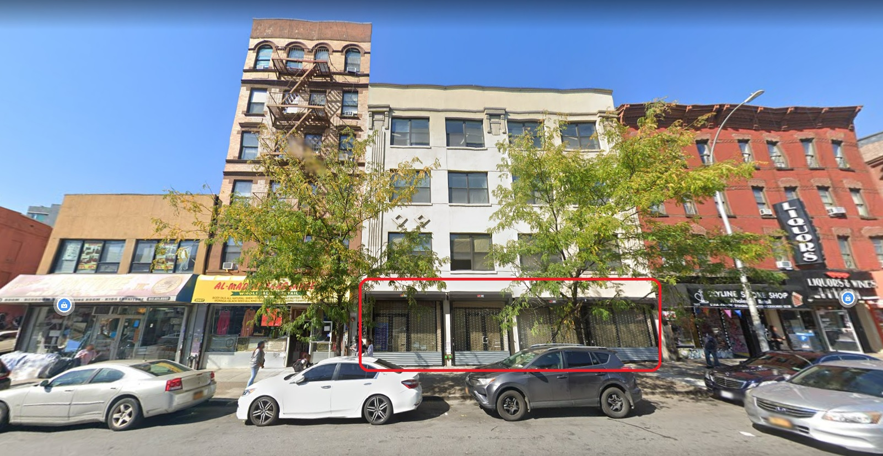

FOR MORE INFORMATION CONTACT
Chestnutcommercial.com
917-225-9199

EXTERIOR/INTERIOR PICTURES
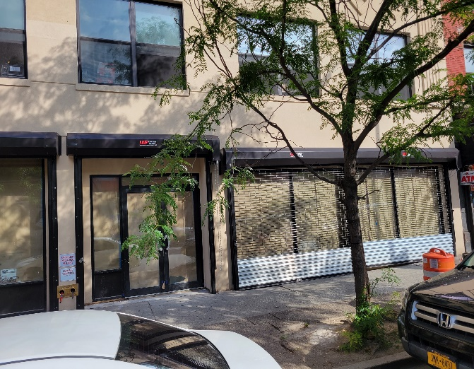
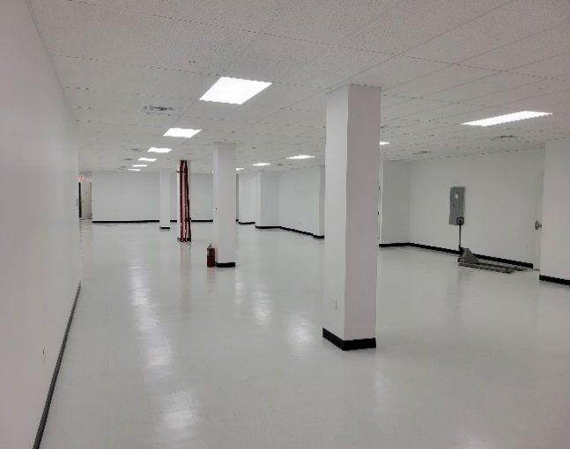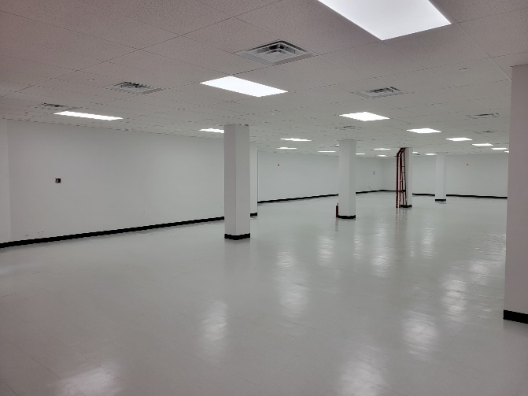
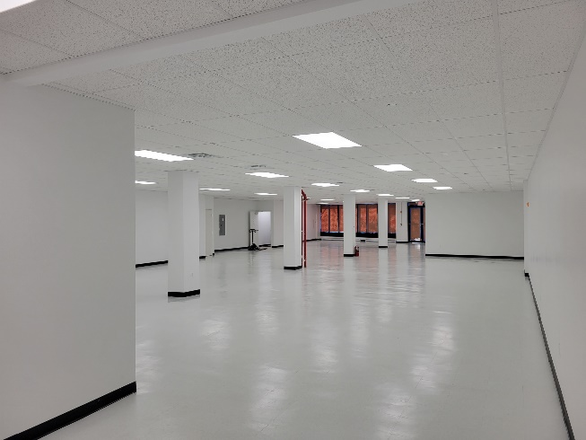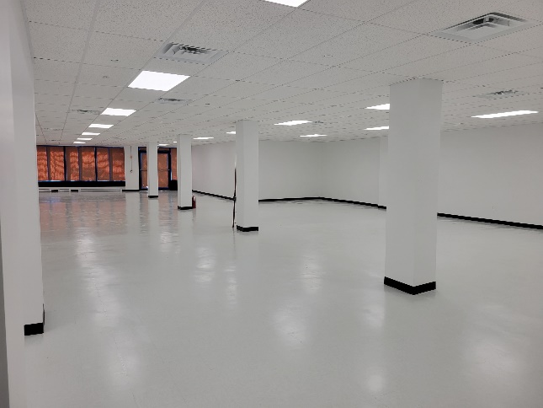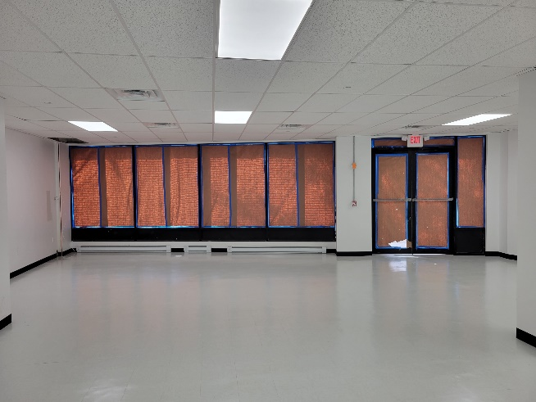

SPACE DETAILS

LOCATION
2999 - 3001 Third Avenue
BTWN East 154 th St. & East 155 th St.
Bronx, New York

BUILDING SIZE
Ground Floor ~3,900 SF
Lower Level ~1,000 SF (TBD)

FRONTAGE
50 feet

CEILING HEIGHT
Ground Floor 12 feet

ASKING RENT:
$18,000 per month ($55 PSF)

POSSESSION
Immediate

FEATURES
- New Glass Store Front
- New Lobby
- New Elevator
- New Electrical
- New Flooring
- New HVAC
- White Boxed
- High Ceilings
- Sprinklers In Place
- Venting Possible

NEIGHBORS
- 271 Covered Parking Garage
- ALDI Food Market
- Walgreens Pharmacy
- Forman Mills Clothing Store
- Dunkin’ Donuts
- Domino’s Pizza
- Boost Mobile
- Mattress Firm

TRANSPORTATION
Subway Station
3rd Avenue & 149th Street

Buses
3rd Ave/E 153rd St Bx15, Bx21

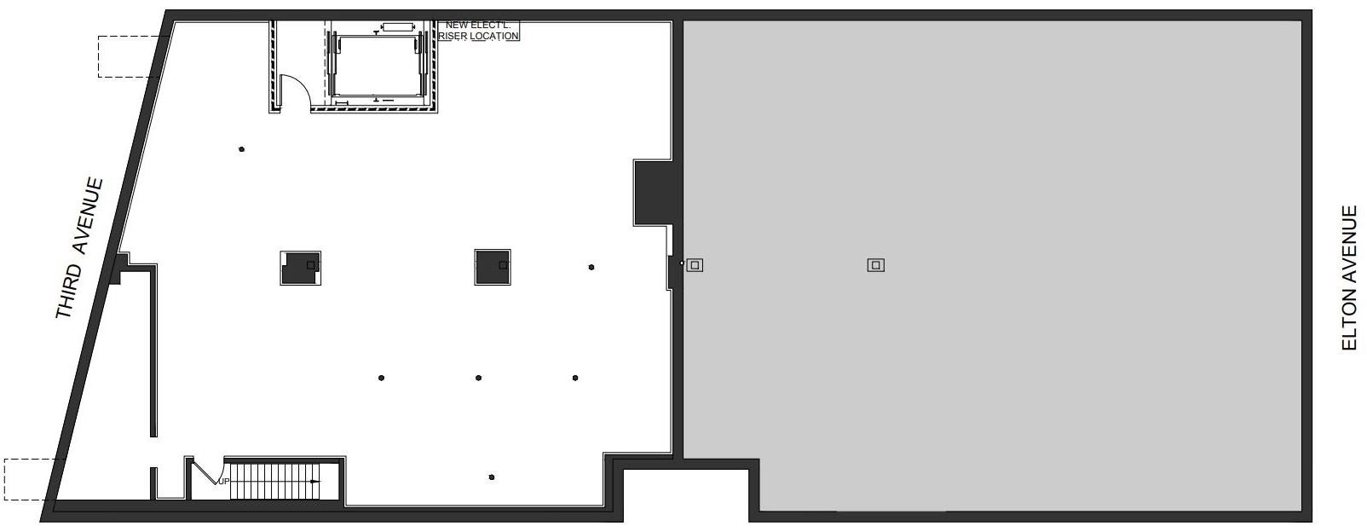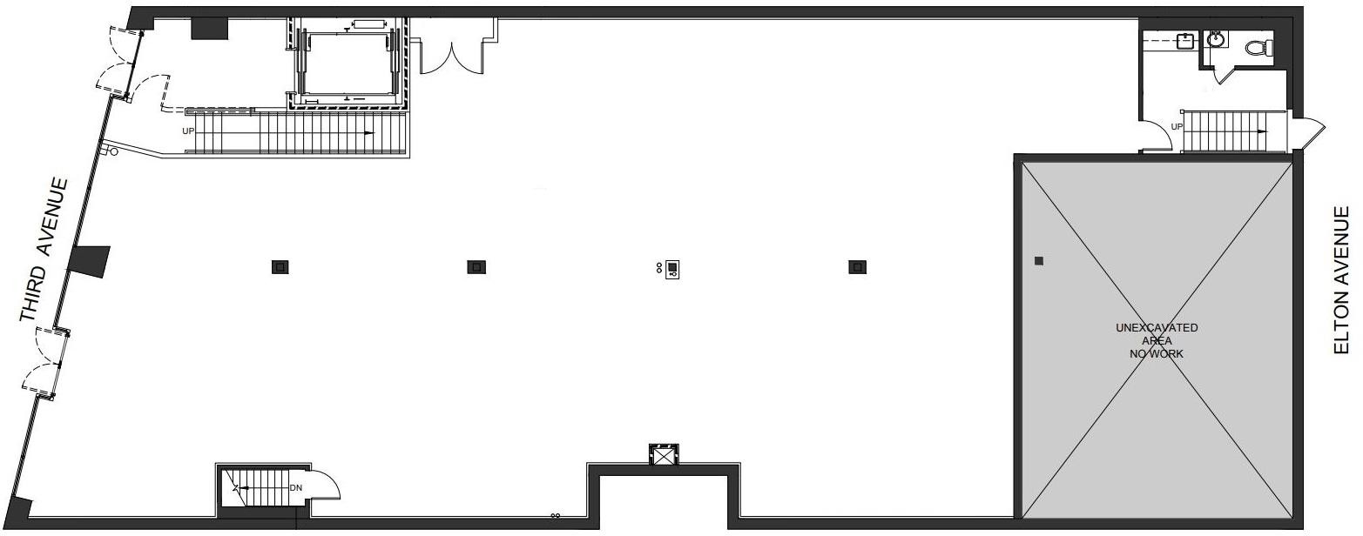FLOOR PLAN
LOWER LEVEL
GROUND FLOOR

